Nick Layman

Project 4 – Farkle

­­­­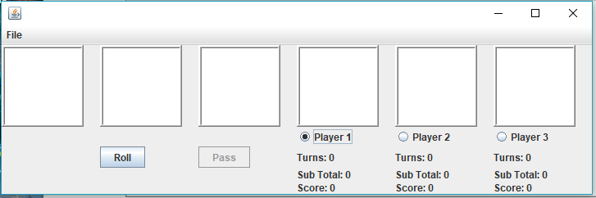

"I pledge that this work is entirely mine, and mine alone (except for any code provided by my instructor).”

X_________________________________

I spent 11 hours and 10 minutes working on this project from November 10 to November 20, 2018 reading the assignment, writing the code, fixing errors, writing proper documentation, making the code look more elegant, and making this write up.